IT Monitoring solution

For

XXXXX

December 1, 2019

Synectiks Inc.
300 Alexander Park Drive, Suite 215
Princeton, NJ 08540
USA

Contents
1. Introduction 2
1.1. Purpose 2
1.2. Need 2
1.3. Users 3
1.4. Location 3
1.5. Responsibilities 3
1.5.1. Functional Responsibilities 3
1.5.2. Generic SLA’s 4
1.5.2.1. Reliability 4
1.5.2.2. Usability 4
1.5.2.3. Performance 4
1.5.2.4. Security 4
2. Use Cases Descriptions 5
2.1. Monitor ISP provided Network Backbone 5
2.2. Deliver Alerts and warning for stated Performance sla violation 8
2.3. Deliver Alerts and warning for stated Availability sla violation 10
2.4. Monitor the performance, availability and network consumption of each server nodes 11
2.5. Deliver Alerts and warning for stated Performance sla violation of Server Nodes 13

Introduction

  - Purpose

This is a Requirements Specification document for a new web-based IT monitoring system for XXX. XXX provide excellent, equitable health care to women and the newborn. This document describes the scope, objectives and goal of the new system. In addition to describing non-functional requirements, this document models the functional requirements with use cases, interaction diagrams. This document is intended to direct the design and implementation of the target system using Synectiks Monitoring Platform.

  - Need

There is a business need to monitor the internet bandwidth performance, usage and bottlenecks and site wise network utilization and take data driven decisions. The goal is to monitor the following system characteristics

- WAN network performance
- WAN availability
- Alerts for any reliability
- RCA for high bandwidth usage
- Server Monitoring
- Business service monitoring

  - Users

Those who will primarily benefit from the new system and those who will be affected by the new system include,

IT Administrator: The new system will provide IT admins with more detailed, accurate and up-to-date network and system performance insights and data for improved RCA of system.

  - Location

The system will be available to internal IT department using the Intranet. IT employees may also use the system from any location and will be able to access restricted areas of the site through a password protection scheme & Role based access control mechanism if they get connected with VPN.

  - Responsibilities
    - Functional Responsibilities
The primary functional responsibilities of the new system:

High Priorities:
- Monitor the WAN Network Utilization. A graph displaying network utilization, understanding network traffic speed and daily bandwidth utilization. It should show detailed bandwidth usage statistics for a WAN link. The graph should also display the high utilization of network in a specific site. System should have the ability to set thresholds for excess bandwidth utilization and notifies you via email and SMS when the threshold value is exceeded.

- Monitor the availability and reliability of two WAN connections provided by two different internet service providers. System should send the email and SMS alerts in case any of the ISP provided connection go down. System also should send the notification in case if there is any toggle in primary / secondary connections.

- Monitor the performance, availability and network consumption of each server nodes of the system. System should provide the analytics dashboards that displays about the Uptime, CPU Usage, RAM utilization, Processor, Disk Details, Disk Activity, System Temperature, Server alerts (Hardware Status warnings), Network IN/OUT of the server and if it went down or set thresholds exceed then alert email and SMS should be sent respective team or group.
Medium Priorities:
- System should have the ability to identify the root cause of High Network Utilization (Example: Download, Trojan or Virus). The requirement would necessitate to install some network packet capture tool that works in tandem with the Synectiks monitoring system.

Low Priorities:
- Monitor the availability of key application services running in server nodes like the tomcat services. In case the service goes down, systems should send email/sms alert.

    - Generic SLA’s
      - Reliability
- The system shall be completely operational at least x% of the time.
- Down time after a failure shall not exceed x hours.
      - Usability
- A monitoring L1 employee should be able to use the system in his job after x days of training.
- A user who already knows what product he is interested in should be able to locate and view that page in x seconds.
- The number of web pages navigated to access product information from the top page should not exceed x.

      - Performance
- The system should be able to support x simultaneous users.
- The mean time to view a web page over LAN connection shall not exceed x seconds.
- The mean time to upload a dashboard shall not exceed x seconds

      - Security
- The system shall provide RBAC based access dashboard and Components
- Any provisioning would go through appropriate approval process

Use Cases Descriptions

  - Monitor ISP provided Network Backbone

Use Case Name: | Monitor WAN Network ( CLICK FOR SITE DIGRAM LINK BELOW )
Actors: | Network Administrators
Summary: | In order to effectively monitor the WAN network, the IT admin should have real time analytics dashboard showing the important KPI to monitor.
Triggers: | It Admin logs in the monitoring solution as Administrator and navigate to the WAN monitoring dashboard.
Pre-Condition: | The user has admin rights to log in to monitoring system and access to wan monitoring dashboards.
Basic Flow: | - Using credentials Admin logs in to monitoring application.  - System will check login credential and validate the role of user.  - System will then display the home page of the application with a drop-down link of different available dashboards.  - Admin will then select the Network Monitoring Dashboard from the list of available dashboards.  - System will then display the Network Monitoring Dashboard  - Network Monitoring Dashboard will show the two isp provider WAN availability and performance details as depicted in dashboard.
Alternate  Flows: | 4A1 :  - Admin select the site wise network performance Dashboard from the list of available dashboards.  - System will then display the SITE WISE NETWORK DASHBOARD  - SITE WISE NETWORK DASHBOARD will show every site L3 switch port wise incoming and outgoing traffic details as depicted in dashboard.
Post-Condition: | The actor can see the detail KPI of two internet connected ports and bandwidth usage.
Extension Points: | None
Prototype Link: | NA

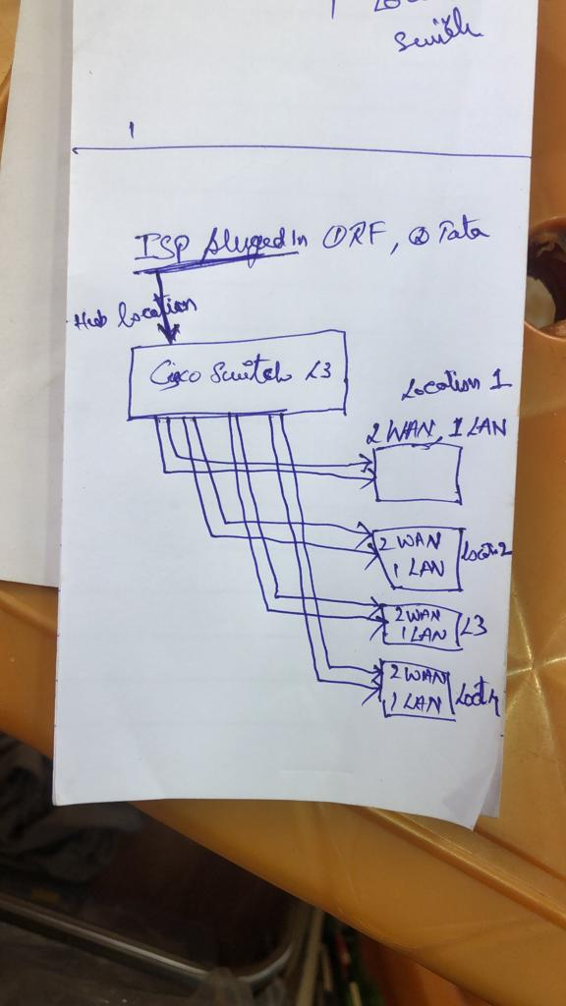

Site Diagram

Network Monitoring Dashboard

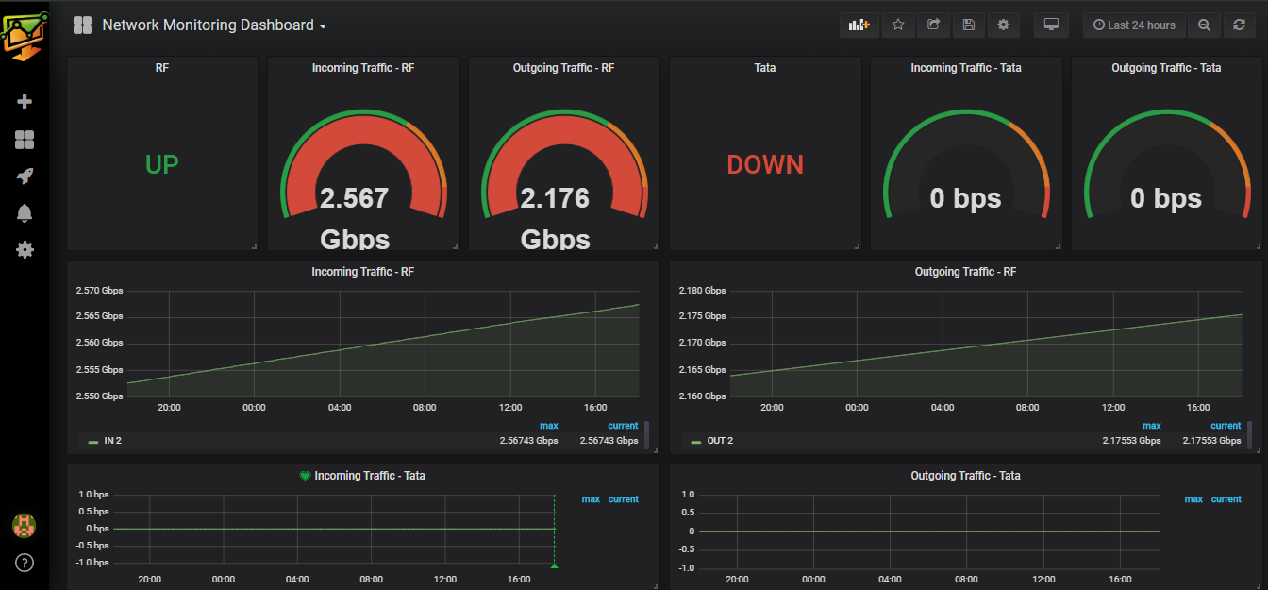

Site wise Network Details
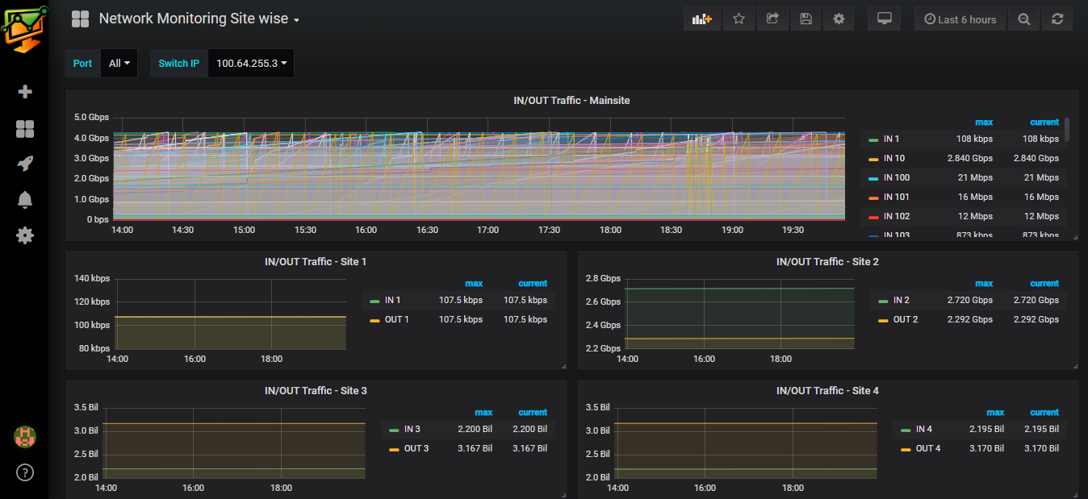

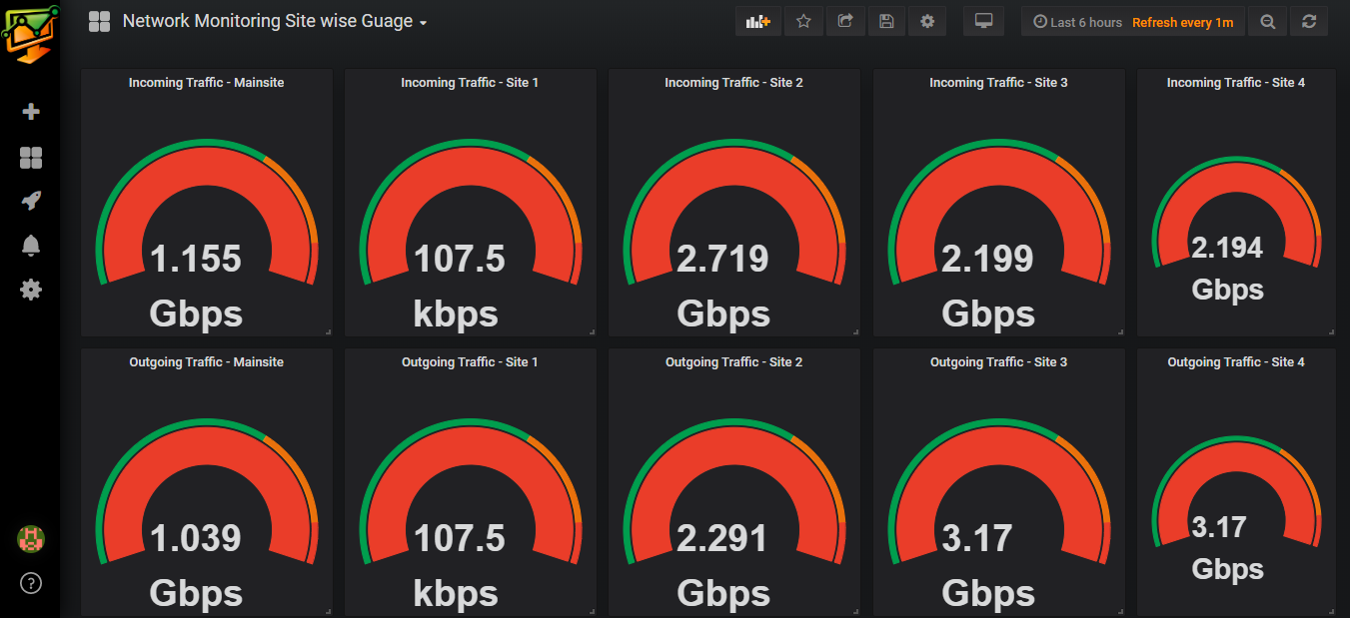

  - Deliver Alerts and warning for stated Performance sla violation

Use Case Name: | Alerts and Warning for Network Performance degradation.
Actors: | Network Administrators
Summary: | In order to effectively monitor the WAN network, the IT admin should have alert and alarm in case any sla pertaining to the main site and child site network is violated.
Triggers: | Any performance SLA violation, sla’s are stated in Basic & Alternate Flows
Pre-Condition: | The user has admin rights to log in to monitoring system to see the alerts also has access to email system to see email alerts and have access to slack in mobile to receive slack alerts in mobile.
Basic Flow: | - Using credentials Admin logs in to monitoring application.  - System will check login credential and validate the role of user.  - System will then display the home page of the application with a drop-down link of different available dashboards.  - Admin select the site wise network performance Dashboard from the list of available dashboards.  - System will then display the SITE WISE NETWORK DASHBOARD  - SITE WISE NETWORK DASHBOARD will show every site L3 switch port wise incoming and outgoing traffic details as depicted in dashboard.  - Admin will be able to set the threshold for any ports inbound & outbound traffic and create alerts by visiting to any specific site switch performance statistics.  - System generates the alerts and warning as and when ports traffic goes beyond or below the threshold mentioned in alert templates.  - System send the email alerts and mobile alerts as specified in the sample format. ( email-alerts & mobile-alerts ).
Alternate  Flows: | 7A1 :  - Admin sets the thresholds for master site dashboard ports, primarily the WAN ports connected to ISP  - System generates the alerts and warning as and when ports traffic goes beyond or below the threshold mentioned in alert templates.  - System send the alert to the destinations with a message formatted as “The outbound traffic of WAN1 port of master switch has exceeded its threshold limit of X MB/s”  7A2 :  - Admin sets the thresholds for master site dashboard ports, primarily the ports connected to different sites.  - System generates the alerts and warning as and when ports traffic goes beyond or below the threshold mentioned in alert templates.  - System send the alert to the destinations with a message formatted as “The inbound traffic of site1 connected port of master switch has exceeded its threshold limit of X MB/s”  7A3 :  - Admin sets the thresholds for every sites switch dashboard ports, primarily the ports connected to main site.  - System generates the alerts and warning as and when ports traffic goes beyond or below the threshold mentioned in alert templates.  - System send the alert to the destinations with a message formatted as “The outbound traffic of site1 has exceeded its threshold limit of X MB/s”
Post-Condition: | The actor can see the alerts in email and slack.
Extension Points: | None
Prototype Link: | NA

Email Alerts Sample

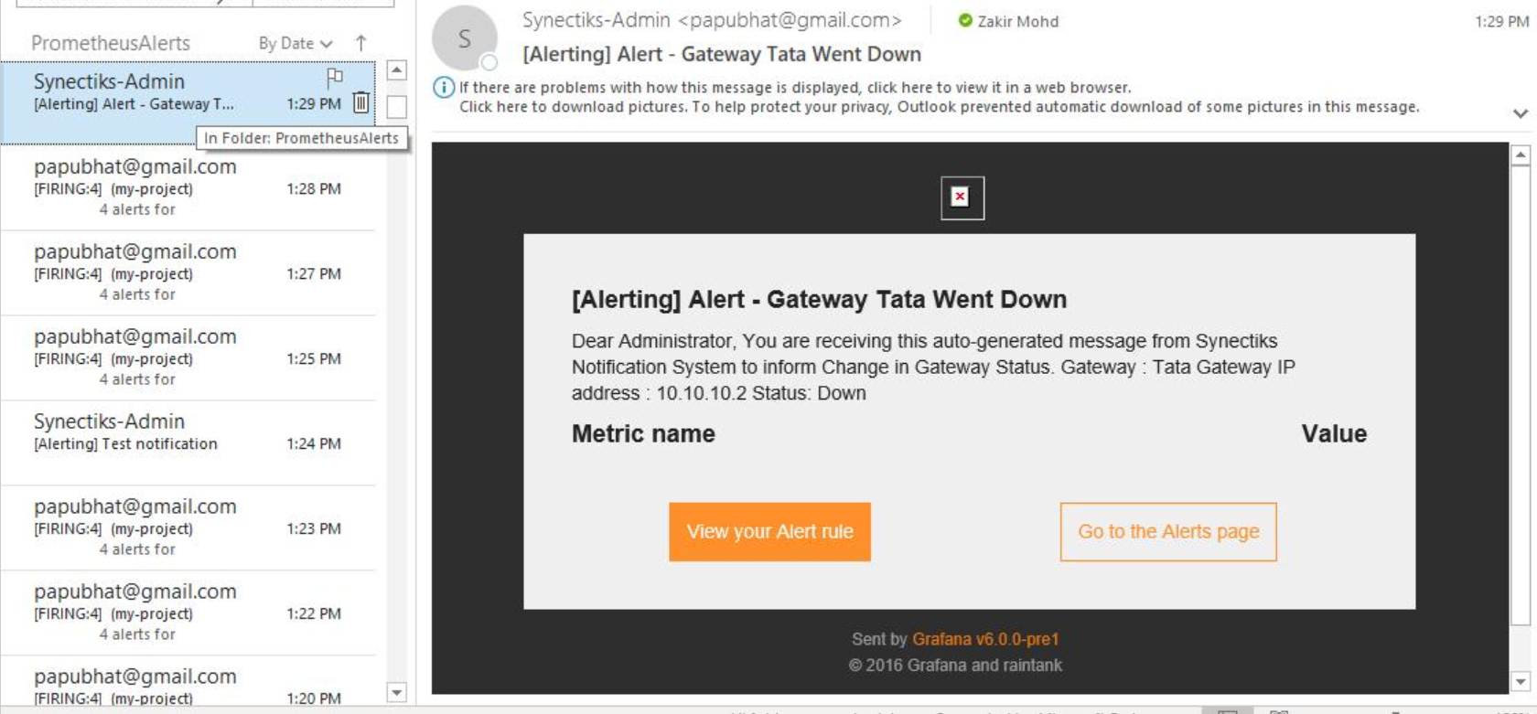

Mobile Alerts in SLACK
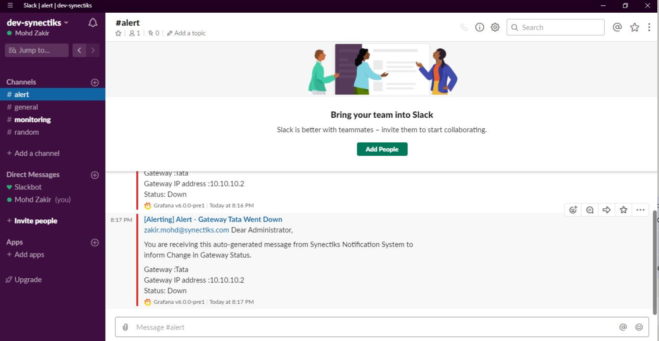

  - Deliver Alerts and warning for stated Availability sla violation

Use Case Name: | Alerts and Warning for ISP Network availability.
Actors: | Network Administrators
Summary: | In order to effectively monitor the WAN network, the IT admin should have alert and alarm in case any sla pertaining to the main site ISP availability is violated.
Triggers: | Any performance SLA violation, sla’s are stated in Basic & Alternate Flows
Pre-Condition: | The user has admin rights to log in to monitoring system to see the alerts also has access to email system to see email alerts and have access to slack in mobile to receive slack alerts in mobile.
Basic Flow: | - Using credentials Admin logs in to monitoring application.  - System will check login credential and validate the role of user.  - System will then display the home page of the application with a drop-down link of different available dashboards.  - Admin select the site wise network performance Dashboard from the list of available dashboards.  - System will then display the Network Monitoring Dashboard  - Network Monitoring Dashboard will show the UP/ DOWN status of both the ISP provided WAN connection.  - Admin will be able to set the alerts for the connection status toggle.  - System generates the alerts and warning when the connection status is changed.  - System send the email alerts and mobile alerts as specified in the sample format. ( email-alerts & mobile-alerts ).
Alternate  Flows: | None
Post-Condition: | The actor can see the alerts in email and slack.
Extension Points: | None
Prototype Link: | NA

  - Monitor the performance, availability and network consumption of each server nodes

Use Case Name: | Monitor Server Nodes
Actors: | Network Administrators
Summary: | In order to effectively monitor the WAN network, the IT admin should have real time analytics dashboard showing the important KPI to monitor the server nodes performance.
Triggers: | It Admin logs in the monitoring solution as Administrator and navigate to the WAN monitoring dashboard.
Pre-Condition: | The user has admin rights to log in to monitoring system and access to wan monitoring dashboards.
Basic Flow: | - Using credentials Admin logs in to monitoring application.  - System will check login credential and validate the role of user.  - System will then display the home page of the application with a drop-down link of different available dashboards.  - Admin will then select the Linux Server Monitoring Dashboard from the list of available dashboards.  - System will then display the LINUX SERVER MONITORING DASHBOARD  - LINUX SERVER MONITORING DASHBOARD will show the Uptime, CPU Usage, RAM utilization, Processor, Disk Details, Disk Activity, System Temperature as depicted in dashboard.
Alternate  Flows: | 4A1 :  - Admin select the Windows Server Monitoring Dashboard from the list of available dashboards.  - System will then display the WINDOWS SERVER MONITORING DASHBOARD.  - WINDOWS SERVER MONITORING DASHBOARD will show the Uptime, CPU Usage, RAM utilization, Processor, Disk Details, Disk Activity, System Temperature as depicted in dashboard.
Post-Condition: | The actor can see the detail KPI of server nodes.
Extension Points: | None
Prototype Link: | NA

Linux Server Monitoring
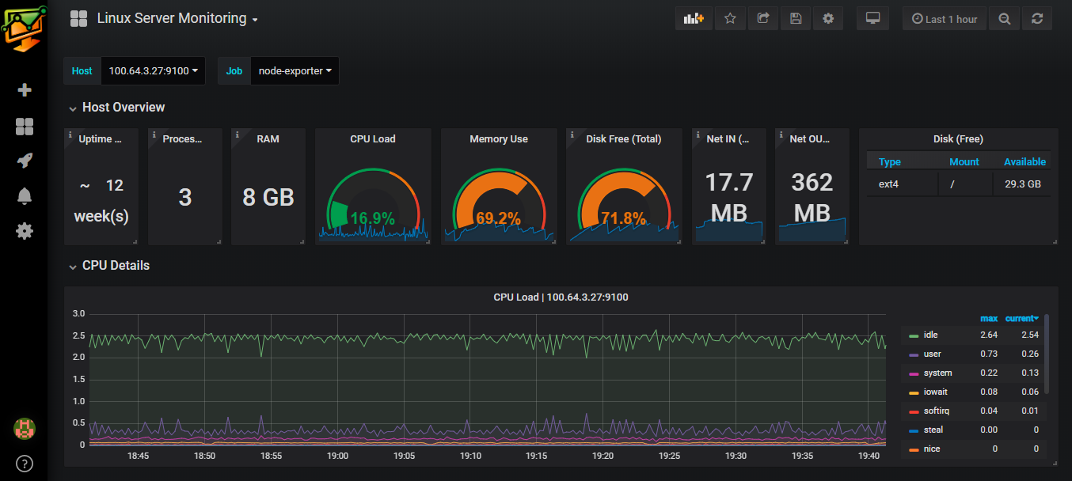

Windows Server Monitoring

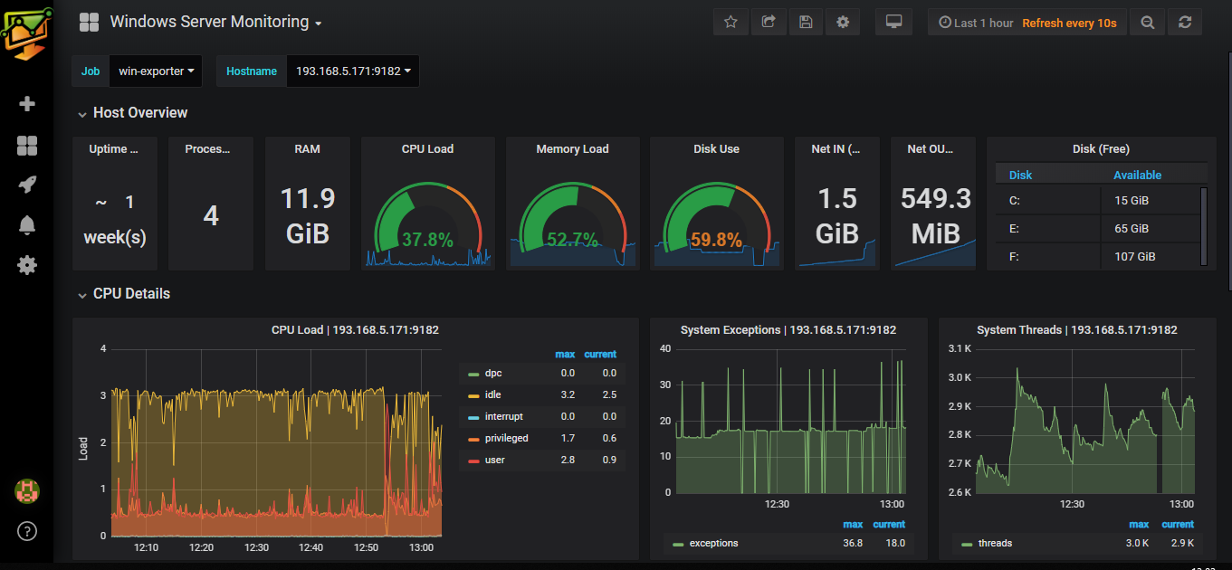

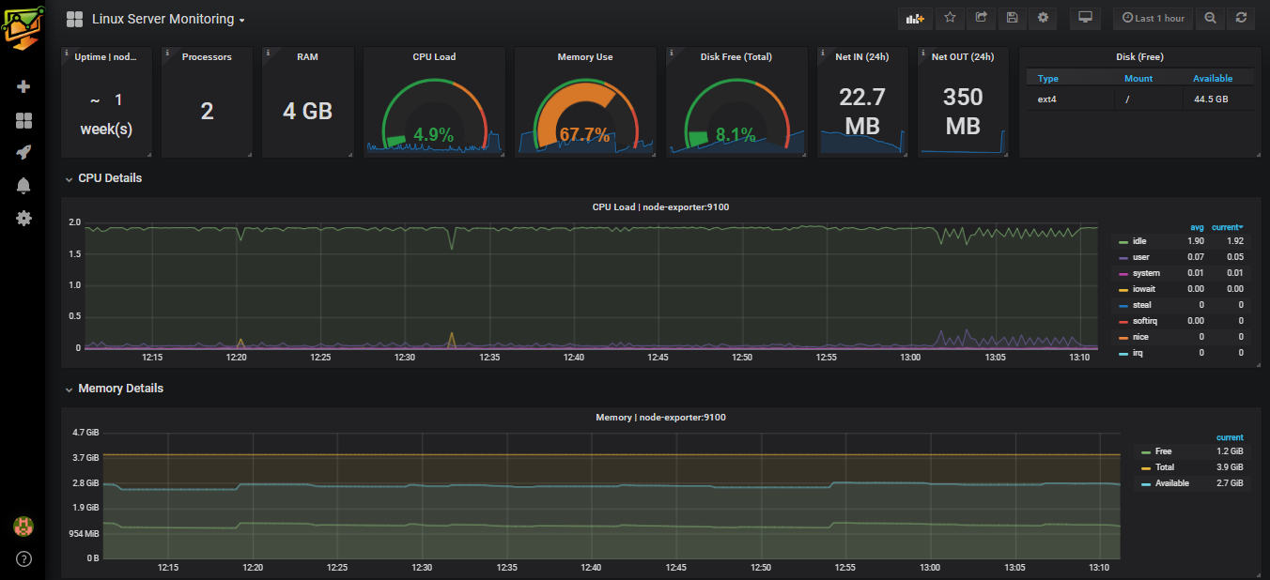

  - Deliver Alerts and warning for stated Performance sla violation of Server Nodes

Use Case Name: | Alerts and Warning for Server Nodes Performance.
Actors: | Network Administrators
Summary: | In order to effectively monitor the WAN network, the IT admin should have alert and alarm in case any sla pertaining to the server performance is violated.
Triggers: | Any performance SLA violation, sla’s are stated in Basic & Alternate Flows
Pre-Condition: | The user has admin rights to log in to monitoring system to see the alerts also has access to email system to see email alerts and have access to slack in mobile to receive slack alerts in mobile.
Basic Flow: | - Using credentials Admin logs in to monitoring application.  - System will check login credential and validate the role of user.  - System will then display the home page of the application with a drop-down link of different available dashboards.  - Admin will then select the Linux Server Monitoring Dashboard from the list of available dashboards.  - System will then display the LINUX SERVER MONITORING DASHBOARD  - Admin will be able to set the threshold for CPU / Memory / Disk and create alerts by visiting to any specific performance dashboard.  - System generates the alerts and warning when the SLA is violated.  - System send the email alerts and mobile alerts as specified in the sample format. (node performance alerts ).
Alternate  Flows: | 4A1 :  - Admin will then select the Windows Server Monitoring Dashboard from the list of available dashboards.  - System will then display the WINDOWS SERVER MONITORING DASHBOARD  - Admin will be able to set the threshold for CPU / Memory / Disk and create alerts by visiting to any specific performance dashboard.  - System generates the alerts and warning when the SLA is violated.  - System send the email alerts and mobile alerts as specified in the sample format. ( node performance alerts ).
Post-Condition: | The actor can see the alerts in email and slack.
Extension Points: | None
Prototype Link: | NA

Node Performance Alerts

